**Name: _________________________ Teacher: __________**

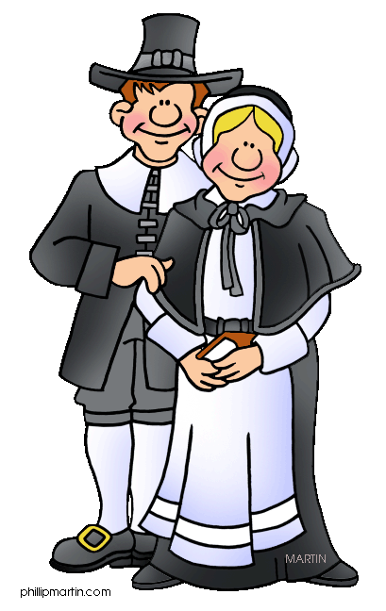**Chapters 6 Social Studies Test**

***Remember: Online practice is available*** [*https://student.teachtci.com/student/sign_in*](https://student.teachtci.com/student/sign_in)

**What to Know:**

* All vocabulary words for chapters 6:

settlement colonist Plymouth

Roanoke democratic marsh

Jamestown ally

* Problems faced by the colonists in Roanoke, Jamestown, & Plymouth and what they did to solve them (or not)
* Reasons for settling Roanoke, Jamestown, & Plymouth
* The results of King Philip’s War

**Directions: Write the definition for each of these key terms.**

|  |  |
| --- | --- |
| **Roanoke** |  |
|  |
|  |
| **settlements** |  |
|  |
|  |
| **Jamestown** |  |
|  |
|  |
| **Plymouth** |  |
|  |
|  |
| **democratic** |  |
|  |
|  |
| **ally** |  |

**Directions: Answer the following questions.**

**What caused the first people who came to Roanoke to give up and go home?**

|  |
| --- |
|  |
|  |
|  |
|  |
|  |

**What took Captain John White so long to return to Roanoke?**

|  |
| --- |
|  |
|  |
|  |
|  |
|  |

**What did Captain John White’s men find when they returned to Roanoke?**

|  |
| --- |
|  |
|  |
|  |
|  |
|  |

**Describe several problems with the place settlers chose to build Jamestown.**

|  |
| --- |
|  |
|  |
|  |
|  |
|  |

**Why did Jamestown survive?**

|  |
| --- |
|  |
|  |
|  |
|  |
|  |

**Virginia was more democratic than England. What does “democratic’ mean and why was Virginia considered to be more democratic than England?**

|  |
| --- |
|  |
|  |
|  |
|  |
|  |

**What was the Mayflower Compact?**

|  |
| --- |
|  |
|  |
|  |
|  |
|  |

**What made the first winter difficult for the Pilgrims?**

|  |
| --- |
|  |
|  |
|  |
|  |
|  |

**Draw a picture below showing the landing of the Pilgrims at Plymouth. In the picture include tools the settlers used and natural resources the settlers can used. In addition, include speech bubbles one that explains a problem the Pilgrims faced and one speech bubble to show how that problem can be solved.**

|  |
| --- |
|  |

**Directions: Write the definition for each of these key terms. MATCHING**

|  |  |
| --- | --- |
| **_____ Roanoke** | 1. Town that was started in Virginia in hopes of finding gold and other natural riches. |
| **_____ settlements** | 1. The first English settlement which today is known as the “lost colony”. |
| **_____ Jamestown** | 1. Small communities started by people new to an area. |
| **_____ Plymouth** | 1. Town in present day Massachusetts |

**Answer the following questions:**

Relating to a form of government in which people have the power to rule themselves often through elected representatives.

__________________________________________________________

A person who settles in a colony.

__________________________________________________________

The first successful English colony in North America. It was founded in 1607 in present day Virginia.

**__________________________________________________________**

1. A small community that is started in a new place.

****colonist

****democratic

****Plymouth

****settlement

1. The name of the island where the first English settlement was started in North America in 1587. Is located near the coast of present day North Carolina.

****Roanoke

****colonist

****ally

****marsh

1. A town started in 1620 by early English settlers called Pilgrims. Is in present day Massachusetts.

****marsh

****Plymouth

****ally

****colonist

**2 True/False**

1. One person or nation united with another for a common purpose. → marsh

**TrueFalse**

1. Wet low lying land that is poorly drained. → ally

**TrueFalse**